THE TITLE OF THE ARTICLE

**Marcus Vitruvius Pollio1, Alfred Berg2, and Engelbert Humper3**

1 Department of Architecture, STU Bratislava, Faculty of Civil Engineering, Radlinského 11, 813 68 Bratislava, Slovakia, Email: [Marcus.Vitruvius@stuba.sk](mailto:Marcus.Vitruvius@stuba.sk)

2 Faculty of Architecture, KU Leuven, Hoogstraat 51, 9000 Gent/ Paleizenstraat 65, 1030 Brussel, Belgium, Email: [alfred](mailto:nicola.tesla@kuleuven.be).berg@kuleuven.be

3 Department of Building Construction, STU Bratislava, Faculty of Civil Engineering, Radlinského 11, 813 68 Bratislava, Slovakia, Email: engelbert.humper@stuba.sk

# Abstract

This template explains and demonstrates how to prepare your camera-ready paper for publication. The best is to read these instructions and follow the outline of this text.

Please make the page settings of your word processor to A4 format (21,0 x 29,7 cm); with the margins: bottom 2,0 cm and top 2,5 cm, right/left margins must be 2,0 cm.

Abstract is expected to have 150 – 400 words.

# INTRODUCTION

This template makes available the necessary paragraph and character formats for the easy and unified formatting of your text. Please use only the formatting made available in this format template. Only in this way we can be certain that all of the formatting in the entire proceedings have a uniform format.

# Language

Only manuscripts in the English language will be accepted. The technical program committee reserves the right to reject any manuscript based on the final submission, even if the abstract was previously accepted.

# File format

We strongly recommend to use this document as a basis for writing your article! The purpose of these instructions is to ensure uniformity in the layout and typography of the papers. The headings and subheadings used in these instructions are in the format that should be used in the preparation of the paper. The type font used here and for the paper is WORD Times New Roman 11 point font.

Please send us your articles in two formats. First is Word Processing Document (doc), based on this background. Second paper must be submitted using Adobe’s Portable Document Format (PDF) format. The file must not have Adobe Document Protection enabled, as this prevents us from processing the file. Also, make sure to disable ALL document security.

# Figures and Tables

All figures should be centered on the page. Figure captions should follow each figure and have the format given in Figures 1–2. Vectorial figures are preferred. Also, in order to provide better readability, the font size for figure text should be at least identical to footnote font size.

If bitmap figures are used, please make sure that the resolution is enough for print quality. Figure 1 and 2 illustrates an example of a figure. In the same way as for figures, all tables should be centered on the page, see Tables 1 and 2. Table captions should be above each table and have the format shown in Tables 1–2.

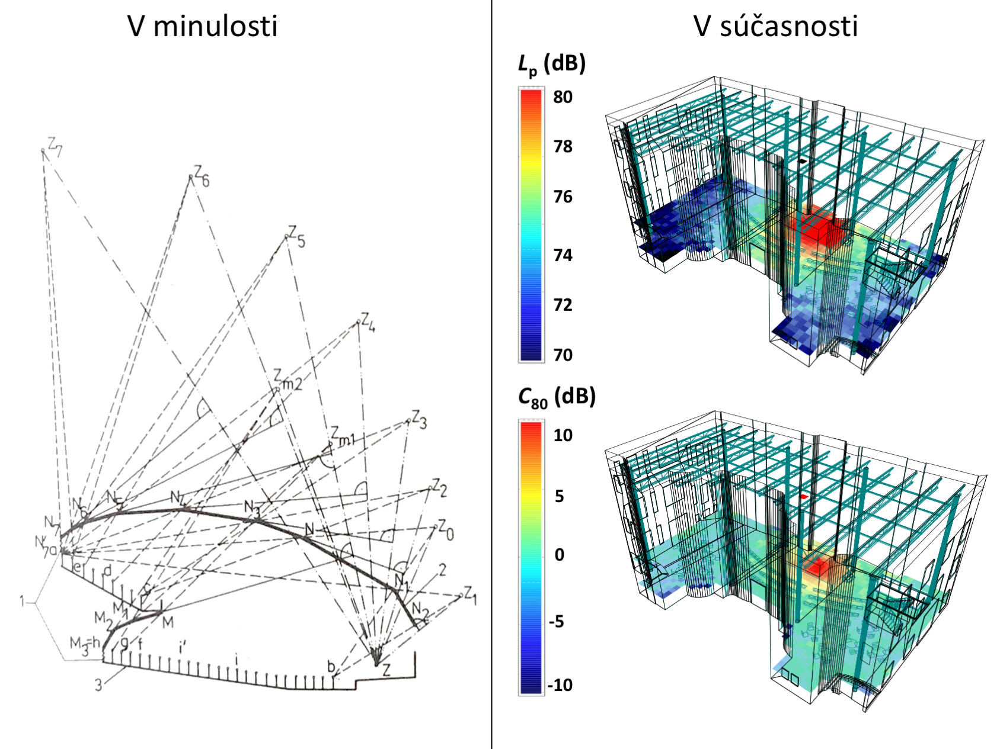

Figure 1. Figure example.

It is necessary to reduce your photos and paste them in the text where you want them to appear. Colour photographs are allowed, though the maximum size of the documentation is 1.5 MB.

The illustrations suitably reduced in size should preferably be located within the text material, but may be located at the end of all text material. The illustrations and captions should be legible without turning the manuscript 90 degrees.

Table 1. Basic table style.

|  |  |  |  |
| --- | --- | --- | --- |
| x | y | z | f(x,y,z) |
| 0.5 | 1.2 | 0.9 | 2.1 |
| 0.7 | 2.5 | 1.0 | 5.0 |

# Equations

Equations should be placed on separate lines and numbered, so that the expression can be referred

$m=\sqrt{r_{S}^{2}+{(z-z_{S})}^{2}}$ $m=\sqrt{r_{S}^{2}+{(z-z_{S})}^{2}}$, (1)

to as equation (1).

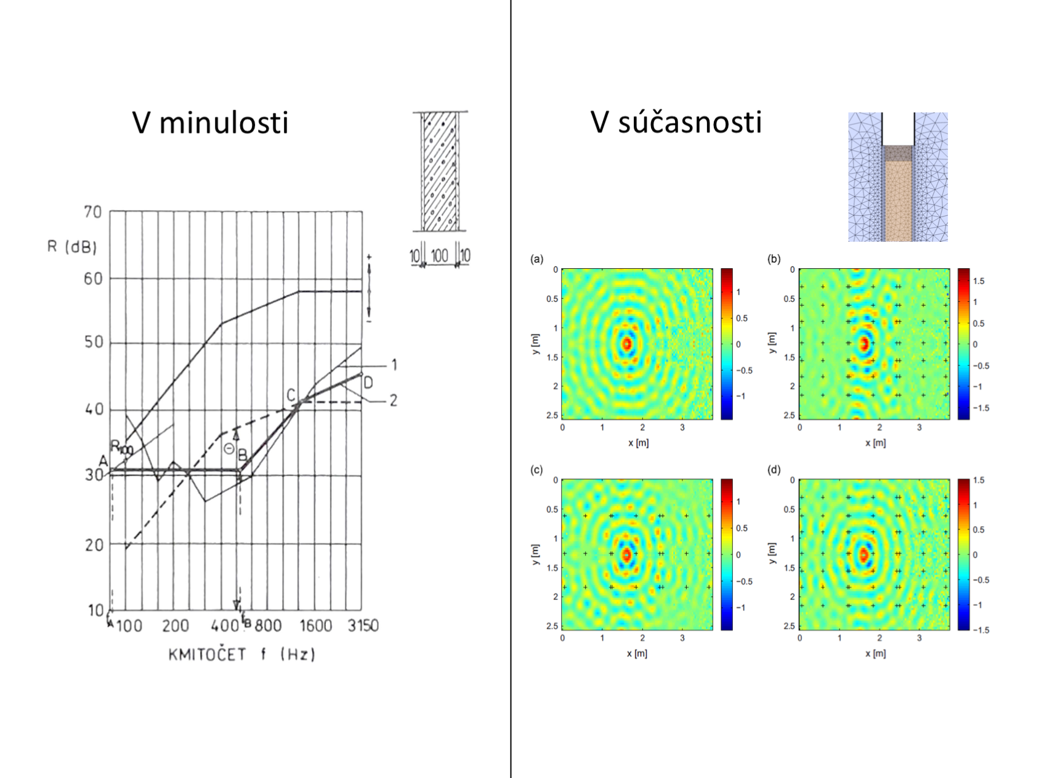

Figure 2. Figure example

# Page numbers

Page numbers will be added to the document electronically, so please do not try to insert page numbers. The maximum number of pages allowed is 6.

This is a text which is repeated many times in order to demonstrate how text floats across columns. This is a text which is repeated many times in order to demonstrate how text floats across columns. This is a text which is repeated many times in order to demonstrate how text floats across columns. This is a text which is repeated many times in order to demonstrate how text floats across columns. This is a text which is repeated many times in order to demonstrate how text floats across columns.

This is a text which is repeated many times in order to demonstrate how text floats across columns. This is a text which is repeated many times in order to demonstrate how text floats across columns. This is a text which is repeated many times in order to demonstrate how text floats across columns. This is a text which is repeated many times in order to demonstrate how text floats across columns. This is a text which is repeated many times in order to demonstrate how text floats across columns.

# Reference format examples

The reference format is the same as shown some examples here, for a journal paper [Brown, 2003], for a book, [Riečanová, 2013], for a conference paper, [name, year], and for a book chapter, [name, year].

Table 2. Table example



# Conclusions

The last section is normally the Summary or Conclusions, and should be labeled as such.

# Acknowledgement

This project has been funded by the research council of country

# References

[1] Marcus Vitruvius Pollio (transl. Morris Hicky Morgan, 1960), *The Ten Books on Architecture*. Courier Dover Publications.

[2] Rychtáriková M., Chmelík, C., Urbán, V. (2018): Nové trendy v stavebnej a priestorovej akustike. Eurostav 7-8/2018, pg.40-44.

[3] Vorländer, M., Thaden, R. (2000): Auralisation of airborne sound insulation in building, Acustica **86,** pg. 70-76.

[4] D. Brown (2003): The Da Vinci Code (1st ed.), US: Doubleday, April 2003.